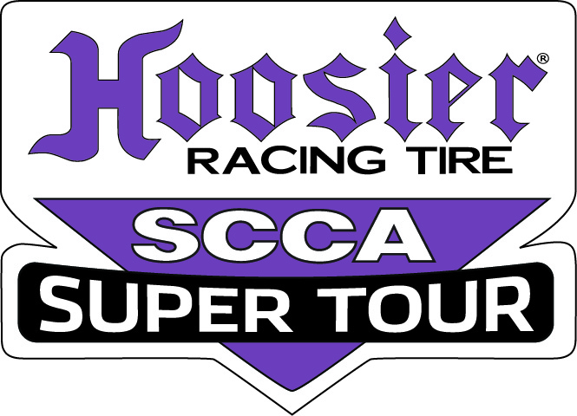
GREEN COUNTRY GRAND PRIX HOOSIER RACING TIRE SUPER TOUR
ARK VALLEY RACE GROUP – NEOKLA, OKLAHOMA, WICHITA REGIONS
Hallett Motor Racing Circuit April 8-9, 2017
17-ST-4873-S

PLEASE TYPE OR PRINT LEGIBLY

Driver’s Name_________________________________________________________________________________________

Phone _________________________________________ Cell Phone ____________________________________________

Address________________________________________City______________________ State______ Zip _______________

E-Mail address_______________________________________________

SCCA Region __________________ Region No. _________ Membership/Lic. No.________________

In emergency notify _______________________________________________________Phone _________________________

Address ________________________________________________________________
Phone __________________________ Organizer Use Only
No/Cls Race
Entrant_____________________________________________Mmbrshp No.________________ Cash Check

CAR INFORMATION Postmark Rcvd
Number Desired (1)_____ (2)_____ (3)_____ MIDIV Pref. No. ____ Majors Series No._____

Class _______ Make/Model ________________________ Transponder # _________________ Posted Confirmed
Displ. ____________ Color_________________
Control No.
Annual Waiver ____________ Waiver Page ___________

READ AND SIGN: I agree to compete under the SCCA General Competition Rules and Supplemental Regulations pertaining to this event. I FURTHER AFFIRM that the car I have entered complies with all the requirements for the class and category in which it is entered. I am a member in good standing of the SCCA.

DRIVER’S SIGNATURE______________________________________________________DATE____________
ENTRANT’S SIGNATURE______________________________________Mbr No. _______________DATE____________
Entrant's Address/street/city/state/zip________________________________________________________________________

AUTHORIZED CREW AND PADDOCK PERSONNEL
Crew Passes: (Free) Paddock Passes: $5.00 each)
1. _____________________________________________ 4. ___________________________________________
2. _____________________________________________ 5. ___________________________________________
3. _____________________________________________ 6. ___________________________________________

Please check fee applicable:
Majors Race $495_____ Second entry/same driver: Both days $350 ____
SM, SRF, SRF3 and FE ADD $20.00 SCCA COMPLIANCE FEE _____
Check method of payment: Check _______ Cash _______ CC _______
Registration available at MotorsportReg.com
Majors Conference Preferred No. Deadline – March 25

MIDIV PREFERRED NO. DEADLINE – March 30 Make checks payable to Ark Valley Race Group
Mail entries to: Betty Martin, Registrar Phone: 918-744-6392 Please do not phone
5421 E 21 Place Between 9 A.M. and 9 P.M. before 9A.M. or after 9 P.M.
Tulsa, OK 74114-2223 E-mail: Btymartin@AOL.com
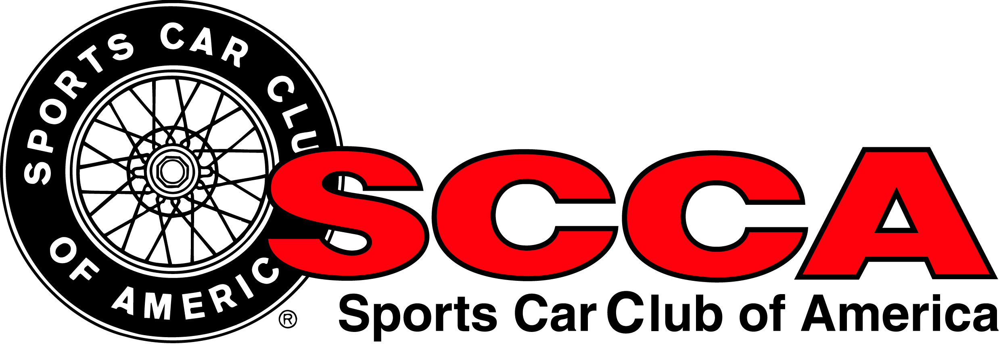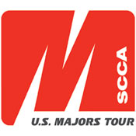

GREEN COUNTRY GRAND PRIX HOOSIER RACING TIRE SUPER TOUR
ARK VALLEY RACE GROUP – NEOKLA, OKLAHOMA, WICHITA REGIONS
Hallett Motor Racing Circuit April 8-9, 2017
17-ST-4873-S

EVENT SCHEDULE
Race Groups
Group 1 | F500, FF, FV | Group 5 | GT1, GT2, GT3, AS, T1
Group 2 | EP, FP, HP, GTL | Group 6 | STL, STU, T2, T3, T4, BS
Group 3 | SM | Group 7 | SRF, SRF3
Group 4 | FA, FB, FC, FE, FM, P1, P2
Friday, April 7, 2017
8:00 AM – 5:00 PM | Track Test Day – Not sanctioned by SCCA. Additional entry fee applies.  Contact HMRC at (918) 356-4814 or connie@hallettracing.net
5:00 PM | Paddock opens for those not participating in the Track Test Day
6:00 PM – 9:00 PM | Registration/Tech – First Floor of the Tower
Saturday, April 8, 2017
7:00 AM – 12:00 PM |  | Registration – First Floor of the Tower
7:00 AM – 12:00 PM |  | Tech Inspection/Scales at the Tech Shed
8:00 AM | 20 minute Qualifying, Group 1 |  | 12:30 PM | 25 minute Race, Group 1
8:30 AM | 20 minute Qualifying, Group 2 |  | 1:10 PM | 25 minute Race, Group 2
9:00 AM | 20 minute Qualifying, Group 3 |  | 1:50 PM | 25 minute Race, Group 3
9:30 AM | 20 minute Qualifying, Group 4 |  | 2:30 PM | 25 minute Race, Group 4
10:00 AM | 20 minute Qualifying, Group 5 |  | 3:10 PM | 25 minute Race, Group 5
10:30 AM | 20 minute Qualifying, Group 6 |  | 3:50 PM | 25 minute Race, Group 6
11:00 AM | 20 minute Qualifying, Group 7 |  | 4:30 PM | 25 minute Race, Group 7
11:30 AM | LUNCH
Saturday Night Participant Dinner at the Tower
Begins approx. 30 minutes after the last session for Workers, Drivers and Crew Members.
Sunday, April 9, 2017
7:30 AM – 12:00 PM |  | Registration – First Floor of the Tower
7:30 AM – 12:00 AM |  | Tech Inspection/Scales at the Tech Shed
8:00 AM | 15 minute Qualifying, Group 1 |  | 11:20 AM | 35 min Race (28 lap max), Group 2
8:20 AM | 15 minute Qualifying, Group 2 |  | 12:00 PM | LUNCH
8:40 AM | 15 minute Qualifying, Group 3 |  | 1:00 PM | 35 min. Race(28 lap max), Group 3
9:00 AM | 15 minute Qualifying, Group 4 |  | 1:50 PM | 35 min. Race(28 lap max), Group 4
9:20 AM | 15 minute Qualifying, Group 5 |  | 2:40 PM | 35 min. Race(28 lap max), Group 5
9:40 AM | 15 minute Qualifying, Group 6 |  | 3:30 PM | 35 min. Race(28 lap max), Group 6
10:00 AM | 15 minute Qualifying, Group 7 |  | 4:20 PM | 35 min. Race(28 lap max), Group 7
10:30 AM | 35 min. Race (28 lap max), Group 1 |  | Thanks for racing with us! Safe Travels!
PLEASE NOTE: Scheduled sessions are approximate and are for planning purposes only. Actual start times may vary based on
forces of nature and on-track incidents. Stewards will not take actions on minor schedule changes.
RACE OFFICIALS
Race Chrmn | Neil Cox | Starter
Race Director | Ken Patterson | Grid | Vicki Jarecke
Series Admin. | Deanna Flanagan | Registration | Betty Martin
Series Tech Admin. | Frank Diringer | T&S | Charlene & Bruce Bettinger
Chief Steward | Peter Olivola | F&C | Chris Kern
Chair SOM | Kenneth Kirkland | Course Marshal | Ken Ragan
Safety Steward | Keith Pfautz
Tech Steward | Art Tapley
Tower Captain | Mike West
GREEN COUNTRY GRAND PRIX HOOSIER RACING TIRE SUPER TOUR
ARK VALLEY RACE GROUP – NEOKLA, OKLAHOMA, WICHITA REGIONS
Hallett Motor Racing Circuit April 8-9, 2017
17-ST-4873-S

SUPPLEMENTAL REGULATIONS
General
- This event, organized by NEOKLA/OKLAHOMA/WICHITA Regions, SCCA, will be held under the 2017 General Competition Rules (GCR) and Category Specifications, as amended for 2017 per “FasTrack”.and will comply with the 2017 Mid-Am Regulations.
- The course is a 1.8 mile road course, asphalt surface, minimum width of 34 feet, with numerous elevation changes.
- Race direction is COUNTERCLOCKWISE.
Majors Program Items
- Free Entry Giveaway: A free entry will be awarded to one driver registering for the event 14 days prior to the event. Driver name will be drawn at the event party or other designated time.
- GRID: Starting positions for the Saturday race will be determined by the fastest time recorded for each car during the preceding qualifying session. Starting positions for the Sunday race will be determined by the fastest time recorded for each car during each of the preceding qualifying sessions and its fastest lap during the Saturday race. Cars arriving at the grid after their group has been dispatched on track may, at the discretion of the Operating Steward, be held at pit out and released at the end of the pack after the field has completed the pace lap.
- SPLIT STARTS: The Race Director will consider requests for split starts and may authorize split starts based on qualifying times.
- RACE LENGTH: Saturday races will be 25 minutes. Sunday races will be 35 minutes (28 lap max)..
- START TIMES: Session times denote when cars will be leaving the grid..
- VICTORY LAPS: Winners of all races will receive a checkered flag. However, for Sunday races only, following the cool down lap, the winners of each class should proceed immediately down pit road where they will receive a checkered flag and be directed on course for a single Victory Lap. Drivers need not wear their helmet or gloves during the victory lap and passengers are permitted in accordance with the GCR. Drivers shall maintain a safe speed and be wary of safety vehicles which may be on course.
- IMPOUND: Saturday races: The top three competitors in each class shall report to impound immediately following the completion of their race. Trophy presentations and photos will occur in the Victory Circle area near impound following the race. Sunday Races: The top three competitors in each class shall report to impound immediately following completion of their race, all other competitors are strongly encouraged to attend the podium festivities following their race. (Impound of all cars is encouraged following Sunday’s races.) Victory celebrations and award ceremony will be conducted in the Victory Circle area near impound following Sunday’s races. U.S. Majors Tour door prizes will be awarded after each group’s podium ceremonies, you must be present to win.
- DECALS: A Hoosier Super Tour decal and a U.S. Majors Tour decal must be displayed on both sides of all competition vehicles. Competition vehicles must also display the official SCCA Club Racing decal per GCR section 9.3.29.C. Stickers will be provided free of charge and may be obtained at registration and/or tech.
- DRIVERS MEETING: Impound All will be given at the end of the first qualifying session for each group to conduct a drivers meeting. Impound will be in the Tech Area.
- QUALIFYING: A driver not qualifying within a maximum of 115% of the recognized track record of his/her class must obtain permission from the Race Director in order to race. In the case of unusual circumstances, the Race Director can waive this rule for the entire event.
HALLETT 115% CUTOFF TIMES

GT1 1:24.792 | HP 1:40.428 | T3 1:36.005 | FE 1:26.453
GT2 1:30.830 | STL 1:37.185 | T4 1:41.991 | FF 1:31.168
GT3 1:33.990 | STU 1:37.326 | SRF 1:38.199 | FM 1:26.791
GTL 1:37.387 | AS 1:37.387 | SRF3 1:34.199 | FV 1:39.623
B-SPEC 1:48.552 | SM 1:41.590 | FA 1:17.622 | F5 1:28.871
EP 1:33.955 | T1 1:33.144 | FB 1:25.497 | P1 NONE..
FP 1:34.867 | T2 1:35.844 | FC 1:24.600 | P2 1:29.281

- SPEC MIATA COMPLIANCE:: At post-race inspection, Spec Miata participants may be instructed by the designated Class Compliance Chief (CCC) to remove part, including but not limited to the cylinder head, for disassembly and/or inspection. Competitors are responsible for performing required disassembly and/or reassembly of their car, as well as any resulting expenses incurred. The CCC will report any findings of non-compliance to the Race Director, who will then determine the need for a Chief Steward’s Action (CSA) or Request for Action (RFA).
- DATA ACQUISITION: Majors staff and their delegates may install data acquisition equipment in a competitor’s car. This program is to assist the CRB in performance balancing. If selected, participation is not optional and is not protestable. The data collected will not be used for compliance purposes.
- CONTACT: All on track body contact (including contact during drafting) that causes a car to act erratically and results in a change in position or a car leaving the course will be investigated. Drivers are encouraged to proactively report to the Race Director (in the Tech area) following a session in which such contact occurred to expedite the investigation process.

GREEN COUNTRY GRAND PRIX HOOSIER RACING TIRE SUPER TOUR
ARK VALLEY RACE GROUP – NEOKLA, OKLAHOMA, WICHITA REGIONS
Hallett Motor Racing Circuit April 8-9, 2017
17-ST-4873-S

- PLEASE NOTE: Schedule session times are approximate and are for planning purposes only. Actual start times may vary based on forces of nature and on-track incidents. Stewards will not take actions on minor schedule changes.
- AWARDS: Trophies for all races will be awarded in accordance with the GCR. Trophies will be presented at the event. Majors points will awarded in compliance with the GCR.
Registration and Entries
- Online entry available at www.motorsportreg.com. Please be sure to provide cell phone numbers when registering for contact at the track if necessary. Registrar: Betty Martin, 5421 E. 21 Place, Tulsa, OK 74114, 918-744-6392, between 9 A.M. and 9:00 P.M. E-mail: Btymartin@AOL.com.
- Entry Fees: Majors Tour - $495; SM, SRF, SRF3,and Formula E add $20.00 for SCCA Compliance fee. Second entry/same driver - $350 for both days. MIDIV drivers wishing to earn points in non-runoffs classes per the MidAm Rules should notify the registrar with the class information.
- PREFERRED NUMBERS: Every effort will be made to honor Conference Preferred Numbers until 14 days (March 25) prior to the event. If two drivers holding the same Preferred Number request that number for the same run group, the number will be assigned to the driver with the earliest request. Secondary preference will be given to MiDiv Preferred number holders. At noon on March 25, all unused Majors reserved numbers will be released on a first-come, first-served basis. MiDiv Preferred Number deadline is Thursday, March 30.
- Since Tech Cards will be printed from the information listed on MSR, drivers are urged to double check the information when submitting your entry.
- DRIVER ELIGIBILITY: Drivers must be a current member of the SCCA and hold an SCCA Full Competition License or SCCA Pro Racing License to participate in this event.
- CAR ELIGIBILITY: Competition is open to all cars conforming to the GCR, as amended.
- Express Registration will be available for drivers holding a Tour annual Registration Card. Express Tech will also be available in the express line for those cardholders that have a valid Annual Tech, 2017 Helmet Sticker, and no notations in their logbook. If eligible, you will only need to bring your logbook to Registration to receive your “event” tech sticker.

Drivers and Crew
- AMB Transponders will be required. It is the responsibility of the driver to replace any transponder that does not work. Drivers are not guaranteed times if the transponder is not working. Drivers with a transponder issue on-track may be notified by a sign bearing the letter “T”, with their car number, at start/finish. (HMRC has transponders available for rental or purchase.)
- No more than 45 cars will be allowed on the track at one time unless permitted by the Executive Steward.
- Race control frequencies are 152.3450 and 157.6050. Do not use these for team communications.
- Admission to restricted areas (false grid, racing pits, tech area, etc.) will be by properly credentialed SCCA Photo ID only. During trophy presentations the Victory Circle area will be designated as a cold area.
- Scales will be open Saturday, 10-1, and Sunday 8-10:30.
- All people except grid workers, starters, officials, and competitors in the race must clear the pre-grid area at the one minute warning. The field will not leave the grid until clearing is complete.
- There will be no attempt at bump starting a vehicle while under flat tow.
- Drivers must have, at a minimum, a race helmet, gloves, and lap belt in place anytime the race car is under flat tow on the race course.
- The track is closed to all vehicular traffic except officials both before and after the event.
- The Race Director or Chief Steward may require fuel testing at Impound
Paddock
- Participants will not be allowed into the track until after 5 P.M. on Friday unless they are participating in the Test Day.
- Racing fuel, air, and water will be available in the paddock
- Speed limit for ALL VEHICLES in the paddock is 10 MPH.
- Bicycles and two, three, and four-wheeled motorized vehicles must be operated by a licensed driver.
- Camping by participants is allowed in non-restricted areas of the track.
- No motor homes, transports, or race cars on trailers are allowed on the track or on the pit-grid area paving.
- No loud music or noise between 10 P.M. and 6:30 A.M.
- All pets must be on a leash and attended at all times.
- No products, concessions, or services shall be sold, advertised, or promoted on Hallett property without the proper liability insurance certificates on file and the express written consent of Hallett Motor Racing Circuit
- Smoking is not permitted on the second floor of the tower building.
- Used oil must be disposed of in the provided receptacles, and used tires must not be left at the track.
- Electrical hookups are available in the paddock area for a fee. Arrangements for the use of electricity must be made with the track management.
- Licensor will assess a charge of $100.00 for each stake or hole put in the asphalt by any competitor or member of licensee's organization.

